Latest Round-ups:
Season 2019/20
#2
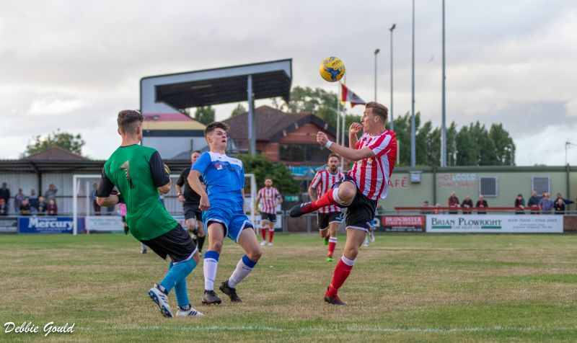
Midweek Action: Bitton extended their excellent start to the campaign with another high-scoring victory at home to Chipping Sodbury Town. Josh Egan has hit the ground running this season, and after netting a treble in the opening day victory away at Hallen, the diminutive forward repeated the trick three days later in their first home fixture. There were also goals for Alex Grimshaw, Harrison Kyte and Ashley Williams, with Bitton eventually running out 6-2 winners. First Division champions Keynsham Town secured their first three points in their new surroundings, defeating Wellington in front of a healthy crowd at Crown Fields. Ben Harris was very much the star for the K’s, setting up Marty Long’s opener, before rifling home from 30 yards to complete the 2-0 win. The other fixture on Tuesday evening ended in a 1-1 draw, with an own goal in the fourth minute of stoppage time rescuing a point for Bridgwater against Cribbs for whom Joe White’s debut goal came close to handing them victory.
24 hours later, Westbury United made it back-to-back wins after defeating Odd Down 3-1 at Meadow Lane. The opening goal came in the closing stages of the first half, with home debutant Sam Jordan heading United ahead after getting on the end of Ryan Bole’s corner. A successful penalty from Jason Henley doubled the hosts advantage, before Connor Biggins hit back for the Bath side who were also looking to maintain their 100% start to the season. Westbury wrapped up victory late on however, with Dan Kovacs smashing the ball home from close range after Dan Price’s goalbound header had been blocked on the goalline.
Action from Bridgwater’s midweek draw with Cribbs at Fairfax Park, courtesy of Debbie Gould.
FA Cup: On This seasons FA Cup action got underway on a wet Friday evening down in Devon, where Plymouth Parkway became the first side to gain progress to the next round after defeating Premier Division rivals Buckland 1-0 at Bolitho Park. The only goal of the game came on the stroke of half-time, with Jack Calver firing home after being played in by Adam Carter.

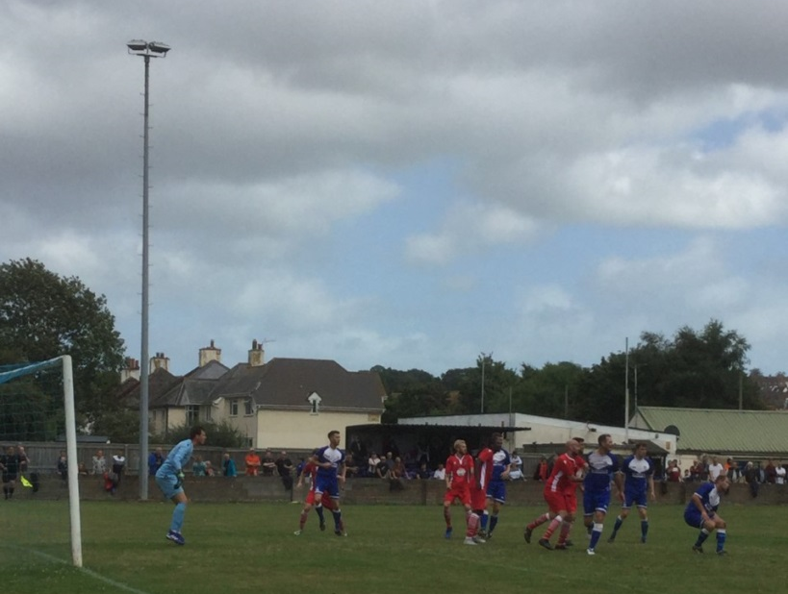
Clevedon Town left it late before claiming a 2-1 victory away at Saltash United, with Lucas Vowles scoring their winner five minutes from time after George King’s opener had been cancelled out earlier in the contest. Clevedon will be joined in the next round by Bridgwater Town, for whom Dave Thorne scored on the hour mark during their 1-0 win at home to Hallen. In an entertaining affair at Bowdens Park, Bradford Town hung on to claim a hard-earned 3-2 victory away at Cheddar. Following a goalless first half, the Premier Division side piled on the pressure at the beginning of the second period, with former Melksham frontman Neikell Plummer banging in a six minute hat-trick. The Cheesemen never lay down however, and a late double from Adam Jones nearly saw them claim a replay, but the Bobcats held out to book their spot in the next round. An excellent second half performance from Street propelled them to a 4-1 win at home to Odd Down. Jay Murray’s 39th minute effort had handed the Bath side the half-time lead, which they relinquished within 60 seconds of the restart when Kyle Strange grabbed an equaliser for the Cobblers. Substitute Dan Linham then put Street ahead midway through the second half, with further goals from Strange and Kameron Andrews wrapping up an impressive comeback at the Tannery Ground. Bitton relied on a late winner by Tristan Plummer to beat Bridport 2-1, to collect their third victory of the week. Having taken an early lead through Matt Groves, Bitton saw their advantage disappear following a Ryan Dovell free-kick, with Plummer then striking a late winner in the final ten minutes to confirm the home side’s progress. A pair of goals at the end of the first half from Aaron Denny and Jordan Harris proved to be enough for Exmouth Town who toppled fellow Devon outfit Barnstaple 2-0. Another side to extend their 100% start were Tavistock, with three second half goals helping them to secure a 3-0 win at home to Hengrove Athletic. Liam Prynn scored twice for the hosts, sandwiching a goal from Jack Crago as Tavistock enjoyed their first run-out at Langsford Park this season.
Action from Exmouth’s 2-0 victory over Barnstaple, courtesy of John Pool.

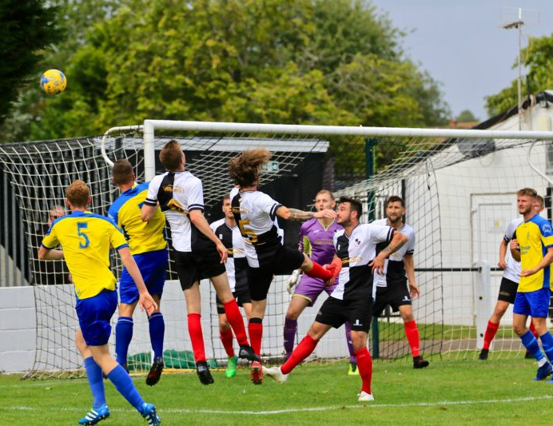
Craig Parsons’ third minute effort proved to be enough for Brislington who ran out 1-0 victors at Keynsham Town, while goals from Craig Loxton, Asa White and Jack Fillingham saw Shepton Mallet pull off a 3-1 triumph at home to Cadbury Heath. There was 1-0 defeat for Westbury at home to Fareham Town, with Chipping Sodbury also knocked out after losing 3-2 away at Dunstable despite a brace from the in-form Sam Makepeace. Cribbs and Wellington will meet in a replay on Tuesday evening, after they drew 1-1 in Bristol. Both sides started well, with Jacob Hodgson putting the home side ahead in the 5th minute, only for Wellington to grab their equaliser six minutes later through Connor Pengelly.
Players from Shepton Mallet and Cadbury Heath challenge for a header during their FA Cup tie, courtesy of Haydn Jones.
Sunday’s tie saw Roman Glass St George come out on top in a five-goal thriller away at Winslow United to claim their first FA Cup victory in 66 years. After falling behind to an early penalty, Roman Glass turned the game around with Ryan Radford scoring either side of the break to hand the visitors a 2-1 advantage. Winslow levelled things up 20 minutes from time, but with a replay looking likely, the Western League outfit had other ideas, scoring a late winner through Steve Fitzpatrick to set up a tie away at Didcot Town in the next round.

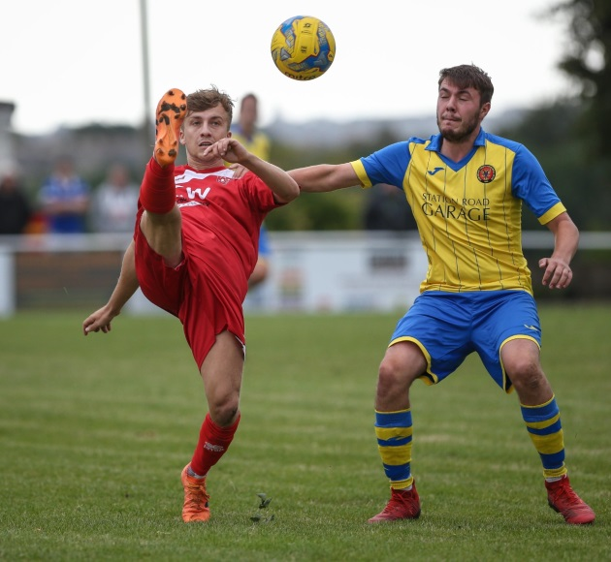
First Division: The First Division action got underway on Friday evening, with Wells overturning an early deficit to defeat Oldland Abbotonians 4-1. The hosts went ahead in the opening minute of the game through Cash Vinall, but it was all downhill from there for the O’s who conceded an equaliser midway through the first half to Harry Foster. Tom Hill then handed Wells the lead three minutes before the interval, with Foster scoring twice during the second half to claim a hat-trick. Saturday’s standout result occurred at the Southfields Rec, where Radstock stormed to a 7-2 victory at home to Corsham Town. The two sides played out a pair of draws last season, but it was the Miners who laid down an early season marker this time around with the ever-prolific James Rustell bagging a hat-trick. Further goals for the home side came from Morgan Skipp, Sam Gregory, Scott Gregory and Jack Biddiscombe, with Josh Bright and Jamal Chevolleau scoring consolation strikes for the stunned Reds.
Action from Radstock’s barnstorming 7-2 victory over Corsham. Image courtesy of John Cuthbertson.

Bishop Sutton responded excellently to their opening day defeat, beating Welton Rovers 3-0 despite suffering two red cards in the first half. Sutton claimed a 19th minute lead at West Clewes when Sam Downes reacted quickest to a loose ball in the box, but the visitors then threatened to undo all of their hard work, losing both Nathan Rendell and Adam Mahdi just prior to half-time. The nine-men battled on in the second half, capitalising on a Rovers sin bin to add two goals to their lead, with Downes’ second goal of the afternoon wrapping up a memorable victory. Stuart Windsor scored his second double in the space of a week to lead Calne Town to a 3-0 win away at Lebeq United. Having accounted for both of the Lilywhites goals in their victory last weekend, Windsor struck twice after the interval at Oaklands Park, either side of a Josh Hard effort to maintain Calne’s winning start. Wincanton Town sit third at the end of gameweek two, eventually coming out on top by three goals to two in a topsy-turvy affair away at Bishops Lydeard. Dan Golden scored the only goal in the first half to put Wincanton ahead, before Miles Quick levelled affairs seven minutes after the interval. Town’s lead was restored 20 minutes from time thanks to Matt Howell, with the home side hitting back instantly via the penalty spot through Luke Bryant. The points looked set to be shared, but Wincanton’s star man Toby Dolton Cole had other ideas, and after opening his account last weekend, their top scorer from last season made it two in two with an 83rd minute winner. Sherborne Town secured their first three points of the season, with goals from Ash Clarke and debutant Alex Murphy leading them to a 2-1 victory away at Longwell Green Sports. Warminster Town were also successful on their travels, beating Devizes 3-1 in an entertaining early-season Wiltshire derby. Warminster are now one of 13 sides to have three points from two games, with Jack Miluk, Charlie Walton and debutant Francois Allen all grabbing goals in the victory, while Devizes suffered a second defeat despite drawing level at the end of the first half through Jack Hopper. Almondsbury were also successful by three goals to one, with their first win of the campaign coming away at the winless Ashton & Backwell United. Having drawn a blank at home last weekend, the Almonds will be happy with their productive afternoon in front of goal at the Lancer Scott Stadium where Greg Parr, Matt Davies and Dan Lane all found the back of the net. Portishead were another side to claim their first win of the campaign, with goals from Luke Coghlan, Paddy Royal and substitute Dan Parslow helping them defeat Bristol Telephones 3-0.
Reporter Wanted
An opportunity has arisen to compile the Western League report for publication in the Non-League Paper. The paid position requires a weekly report covering the Premier Division fixtures every Saturday afternoon.
If you require any more information regarding the role, please contact Dave Watters on 07950 953505 or at dave.watters@greenwayspublishing.com, he would be keen to speak to anybody interested and is hoping to attract a local reporter to cover the league.

Achievement Award
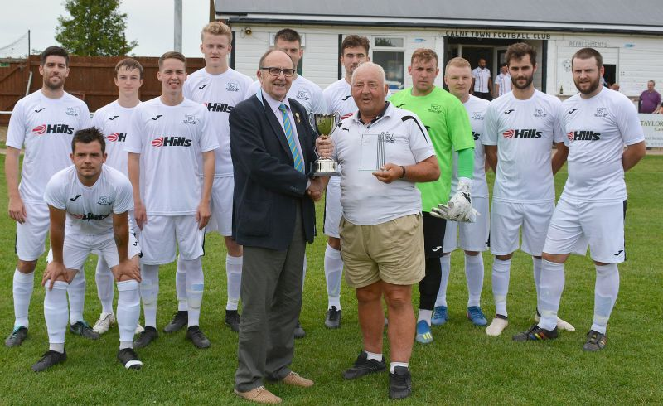

Pat Collier of Calne Town received the recently introduced Western League Achievement Cup from League Vice President Ken Clarke last Saturday.
The cup was donated to the league in memory of past officers and will be awarded annually. Individual clubs and League directors will be invited to nominate candidates for the award.
As the initial recipient, Pat was nominated by Calne Town FC for his outstanding commitment to the club. He first started watching Calne Town at the age of 12 in 1958 and went on to carry out many roles over the 60 years he has been involved. His duties have included - Player, Reserve Team Manager, Supporter, Raffle Seller and Groundsman.
Since retiring, Pat has become Gateman on match days, and most other days he is to be found at the ground carrying out all manner of maintenance jobs. He truly epitomises the type of volunteer desperately needed by all clubs.
Photo courtesy of Dave Gillett.

Be sure to check out the latest podcast, where Ian, Tom & guests recap all the latest news and results from around the Western League. To follow along all season, each broadcast will be available at the following link: http://www.toolstationleague.com/podcasts.php

Latest Results
Tuesday 6th August 2019
Premier Division
Bitton 6-2 Chipping Sodbury Town 146
Bridgwater Town 1-1 Cribbs 237
Keynsham Town 2-0 Wellington 174
Wednesday 7th August 2019
Premier Division
Westbury United 3-1 Odd Down 133
Friday 9th August 2019
First Division
Oldland Abbotonians 1-4 Wells City 48
FA Cup – Extra Preliminary Round
Plymouth Parkway 1-0 Buckland Athletic 181
Saturday 10th August 2019
FA Cup – Extra Preliminary Round
Bitton 2-1 Bridport 74
Bridgwater Town 1-0 Hallen 129
Cheddar 2-3 Bradford Town 157
Cribbs 1-1 Wellington
Dunstable Town 3-2 Chipping Sodbury Town
Exmouth Town 2-0 Barnstaple Town 301
Keynsham Town 0-1 Brislington 177
Saltash United 1-2 Clevedon Town
Shepton Mallet 3-1 Cadbury Heath 105
Street 4-1 Odd Down 100
Tavistock 3-0 Hengrove Athletic
Westbury United 0-1 Fareham Town 87
First Division
Ashton & Backwell United 1-3 Almondsbury 31
Bishops Lydeard 2-3 Wincanton Town 68
Devizes Town 1-3 Warminster Town 145
Lebeq United 0-3 Calne Town
Longwell Green Sports 1-2 Sherborne Town 75
Portishead Town 3-0 Bristol Telephones 48
Radstock Town 7-2 Corsham Town 79
Welton Rovers 0-3 Bishop Sutton 87
Sunday 11th August 2019
FA Cup – Extra Preliminary Round
Winslow United 2-3 Roman Glass St George

Upcoming Fixtures
Tuesday 13th August 2019
FA Cup Replay
Cribbs vs Wellington 19:45KO
Friday 16th August 2019
First Division
Cheddar vs Calne Town 19:45KO
Saturday 17th August 2019 (KICK OFF AT 3.00PM UNLESS NOTED)
Premier Division
Bitton vs Exmouth Town
Bridport vs Plymouth Parkway
Buckland Athletic vs Wellington
Cadbury Heath vs Cribbs
Chipping Sodbury Town vs Bridgwater Town
Clevedon Town vs Shepton Mallet
Odd Down vs Brislington
Roman Glass St George vs Hallen
Street vs Keynsham Town
Tavistock vs Bradford Town
First Division
Almondsbury vs Portishead Town
Bishop Sutton vs Longwell Green Sports
Corsham Town vs Bishops Lydeard
Hengrove Athletic vs Radstock Town
Sherborne Town vs Bristol Telephones
Warminster Town vs Lebeq United
Wells City vs Ashton & Backwell United
Wincanton Town vs Oldland Abbotonians

